**Supplementary Materials** of the article “Identifying typologies among diabetic patients: insights from biopsicosocial factors” by Rosario Callejas Calvo 1, Martín J. Campos Silva 2, Andrés Iturriaga Jofré 3, Sandra Flores Alvarado 4and Felipe A. Medina Marín 5,*

1 Escuela de Medicina, Facultad de Medicina, Universidad de Chile, Santiago, Chile; rosariocallejas@ug.uchile.cl

2 Escuela de Medicina, Facultad de Medicina, Universidad de Chile, Santiago, Chile; martincampos@ug.uchile.cl

3 Departamento de Matemática y Ciencia de la Computación, Facultad de Ciencia, Universidad de Santiago de Chile, Chile; andres.iturriaga@usach.cl

4 Programa de Bioestadística, Instituto de Salud Poblacional, Facultad de Medicina, Universidad de Chile, Santiago, Chile; sfloresa@uchile.cl

5 Programa de Bioestadística, Instituto de Salud Poblacional, Facultad de Medicina, Universidad de Chile, Santiago, Chile; f.medina@uchile.cl

**\*** Correspondence: f.medina@uchile.cl

Table of Contents

**Table S1.** List of variables included in the cluster analysis and their justification 2

**Table S2.** Variable weights used for computing the Gower coefficient 5

**Table S3.** Characterization of the 7 resulting clusters in relation to the studied variables 6

**Figure S1.** Dendrogram obtained from applying Ward’s method to the studied sample 10

**Figure S2.** Average Silhouette coefficient for each of the 7 clusters formed by the k-medoids method 11

**References** 12

# **Table S1.** List of variables included in the cluster analysis and their justification.

|  |  |  |  |  |
| --- | --- | --- | --- | --- |
| **Factor** | **Classification** (risk factor, protective factor, social determinant) | **Reference(s)** | **Question(s) from the ENS 2016-2017 associated with the factor**\* | **Selected or constructed variable(s)** |
| Overweight | Risk factor | Sapunar, 2016; Leiva et al., 2018 | IMC, n3, m4p1 | IMC |
| Waist circumference (visceral fat) | Risk factor | González et al., 2001 | m4p3, m4p3_1, m4p3_2 | m4p3 |
| Sex | Risk factor (female) | Sapunar, 2016; Leiva et al., 2018 | Sexo | Sexo |
| Region | Social determinant | Leiva et al., 2018 | Región | Región |
| Physical inactivity / sedentary lifestyle | Risk factor | Leiva et al., 2018 | a1, a2, a3a, a3b, a4, a5 a6a, a6b, a7, a8, a9a, a9b, a10, a11, a12a, a12b, a13, a14, a15a, a15b, a16a, a16b, a17,a18, a18_esp, a18_esp_sinCodificar, GPAQ | GPAQ |
| Fruit consumption | Protective factor | Durán et al., 2012 | die6, die7 | die6, die7  These variables were used to compute the number of fruit servings consumed in a typical week, thus generating the variable “frutas”. |
| Vegetable consumption | Risk factor (when low) | Rodríguez & Mendoza, 2019 | die8, die9 | die8, die9  These variables were used to compute the number of vegetable servings consumed in a typical week, thus generating the variable “verduras”. |
| Low functionality level | Risk factor | Ghachem et al., 2019 | Puntaje_MMentalMINSAL, ptjePfeffer_MINSAL | Puntaje_MMentalMINSAL, ptjePfeffer_MINSAL.  Both questions were combined into a single dichotomous variable, where an individual is considered to have low functionality if either of the two tests is impaired, thus generating the variable “IndTMP”. |
| Arterial hypertension | Risk factor | Sapunar, 2016 | h2, h11 | h2 |
| Hypercholesterolemia | Risk factor | Sapunar, 2016 | dis2, Colesterol_Total | dis2 |
| Depression | Risk factor | Ghachem et al., 2019; Sartorius, 2018 | cd7, cd9a_18, sd1_F1, sd2_F1, sd3_F1, sd4_F1, sd12_F1, sd13_F1, sd14_F1, sd15_F1, sd16_F1, sd25_F1, sd28_F1, Cantidad_síntomas_depresivos | sd28_F1, Cantidad_síntomas_depresivos  This last question was dichotomized into “0” and “1 or more”. |
| Education level | Social determinant | Sapunar, 2016 | as7_1, as7_corr_1, NEDU1_MINSAL_1, anos_estudio_MINSAL_2 | as7_corr_1 was categorized into a categorical variable named “NEDU” whose 6 levels are: None (originally 1), Pre-school or special education (2-5), Elementary or equivalent (6,7), Secondary or equivalent (8,9), Technical or equivalent (10,11), Higher education (12-14). |
| Vitamin D** | Risk factor | Mohammadi et al., 2022 | o6 | o6 |
| Family history of diabetes | Risk factor | Leiva et al., 2018 | af1b | af1b |
| Diabetes treatment | Protective factor | Alfaro et al., 2000 | di5, di6, di7_1, di7_2, di7_3 | di5, di7_1, di7_2, di7_3 |
| Smoking | Risk factor | Leiva et al., 2018 | ta1, ta2, ta3, ta4, ta5, ta6, ta7, ta8, ta9, ta10_1, ta10_1_esp, ta10_1_esp_sinCodificar, ta10_2, ta10_2_esp, ta10_2_esp_sinCodificar, ta10_3, ta10_3_esp, ta10_3_sinCodificar, ta11_1, ta11_2, ta12_1, ta12_2, ta13_1, ta13_2, ta14_1a, ta14_1b, ta14_2a, ta14_2b, ta14_3a, ta14_3b, ta14_4a, ta14_4b, ta14_5, ta14_6a, ta14_6b, ta14_7a, ta14_7b, ta14_7c, ta14_7s_sinCodificar, ta14a, a14b, ´m2p3, m2p3_1, m2p3_2 | ta3, ta4 |

**\*** Recorded based on their names in the data tables or their designated codes in the respective forms.

** Proposed risk factor for DM1. It is estimated to represent 5-10% of DM cases. (Sapunar, 2016)

# **Table S2.** Variable weights used for computing the Gower coefficient.

|  |  |  |  |
| --- | --- | --- | --- |
| **Variable name** | **Weight** | **Variable name** | **Weight** |
| Región | 1 | GPAQ | 1,5 |
| Sexo | 1 | di7_1 | 1/3 |
| sd28_F1 | 0,5 | di7_2 | 1/3 |
| IMC | 1 | di7_3 | 1/3 |
| h2 | 1 | ta3 | 0,75 |
| di5 | 0,5 | ta4 | 0,25 |
| dis2 | 1 | Frutas | 1 |
| af1b | 1 | Verduras | 1 |
| as28 | 1 | IndSD | 0,5 |
| m4p3 | 1 | IndTMP | 1 |
| o6 | 0,5 | NEDU | 1,5 |

Most of the weights were assigned based on their association with the development or prevalence of diabetes, according to the literature used in this work (Sapunar, 2016; Leiva et al., 2018). For the weighting of o6, the vitamin D variable, the reference (Mohammadi et al., 2022) was used, and for IndSD, the depressive symptoms variable, the references (Ghachem et al., 2019; Sartorius, 2018) were used.

|  |  |  |  |  |  |  |  |  |
| --- | --- | --- | --- | --- | --- | --- | --- | --- |
| **Table S3.** Characterization of the 7 resulting clusters in relation to the studied variables.* | | | | | | | | |
|  | 1 | 2 | 3 | 4 | 5 | 6 | 7 | Total |
| N | 95 | 85 | 113 | 100 | 76 | 115 | 68 | 652 |
| Región, Region (%) |  |  |  |  |  |  |  |  |
| XV. Arica y Parinacota | 8 (8,4) | 4 (4,7) | 3 (2,7) | 3 (3,0) | 5 (6,6) | 4 (3,5) | 3 (4,4) | 30 (4,6) |
| I. Tarapacá | 1 (1,1) | 3 (3,5) | 9 (8,0) | 1 (1,0) | 5 (6,6) | 2 (1,7) | 12 (17,6) | 33 (5,1) |
| II. Antofagasta | 3 (3,2) | 3 (3,5) | 2 (1,8) | 4 (4,0) | 1 (1,3) | 0 (0,0) | 5 (7,4) | 18 (2,8) |
| III. Atacama | 5 (5,3) | 2 (2,4) | 7 (6,2) | 2 (2,0) | 4 (5,3) | 4 (3,5) | 4 (5,9) | 28 (4,3) |
| IV. Coquimbo | 2 (2,1) | 4 (4,7) | 7 (6,2) | 2 (2,0) | 5 (6,6) | 5 (4,3) | 3 (4,4) | 28 (4,3) |
| V. Valparaíso | 6 (6,3) | 9 (10,6) | 6 (5,3) | 4 (4,0) | 3 (3,9) | 13 (11,3) | 4 (5,9) | 45 (6,9) |
| XIII. Metropolitana | 10 (10,5) | 4 (4,7) | 6 (5,3) | 3 (3,0) | 5 (6,6) | 4 (3,5) | 4 (5,9) | 36 (5,5) |
| VI. L. Bdo. O'Higgins | 11 (11,6) | 8 (9,4) | 10 (8,8) | 6 (6,0) | 19 (25,0) | 12 (10,4) | 7 (10,3) | 73 (11,2) |
| VII. Maule | 25 (26,3) | 13 (15,3) | 2 (1,8) | 27 (27,0) | 7 (9,2) | 3 (2,6) | 7 (10,3) | 84 (12,9) |
| VIII. Biobío | 10 (10,5) | 6 (7,1) | 4 (3,5) | 4 (4,0) | 2 (2,6) | 5 (4,3) | 2 (2,9) | 33 (5,1) |
| IX. La Araucanía | 5 (5,3) | 5 (5,9) | 8 (7,1) | 13 (13,0) | 6 (7,9) | 11 (9,6) | 3 (4,4) | 51 (7,8) |
| XIV. Los Ríos | 1 (1,1) | 8 (9,4) | 5 (4,4) | 4 (4,0) | 2 (2,6) | 4 (3,5) | 2 (2,9) | 26 (4,0) |
| X. Los Lagos | 4 (4,2) | 2 (2,4) | 37 (32,7) | 13 (13,0) | 7 (9,2) | 14 (12,2) | 8 (11,8) | 85 (13,0) |
| XI. Aysén | 4 (4,2) | 6 (7,1) | 5 (4,4) | 6 (6,0) | 2 (2,6) | 6 (5,2) | 4 (5,9) | 33 (5,1) |
| XII. Magallanes y Antártica | 0 (0,0) | 8 (9,4) | 2 (1,8) | 8 (8,0) | 3 (3,9) | 28 (24,3) | 0 (0,0) | 49 (7,5) |
| Sexo, Sex = Female (%) | 87 (91,6) | 78 (91,8) | 95 (84,1) | 83 (83,0) | 6 (7,9) | 97 (84,3) | 22 (32,4) | 468 (71,8) |
| sd28_F1, One or more depressive symptoms (%) | 57 (60,6) | 19 (22,4) | 21 (19,6) | 29 (29,3) | 10 (13,2) | 57 (50,0) | 7 (10,6) | 200 (31,2) |
| IMC, BMI (mean (SD)) | 31,4 (5,4) | 30,5 (5,6) | 30,3 (6,0) | 31,3 (5,1) | 31,0 (5,8) | 33,4 (6,4) | 28,2 (4,7) | 31,0 (5,8) |
| h2, current or past high blood pressure diagnosis (%) |  |  |  |  |  |  |  |  |
| No, never | 4 (4,3) | 54 (63,5) | 72 (67,3) | 14 (14,1) | 10 (13,5) | 9 (7,9) | 43 (65,2) | 206 (32,3) |
| Yes, only once | 14 (15,1) | 23 (27,1) | 23 (21,5) | 9 (9,1) | 17 (23,0) | 13 (11,4) | 11 (16,7) | 110 (17,2) |
| Yes, more than once | 75 (80,6) | 8 (9,4) | 12 (11,2) | 76 (76,8) | 47 (63,5) | 92 (80,7) | 12 (18,2) | 322 (50,5) |
| di5, have ever followed a program, treatment, or made a lifestyle change for diabetes or high blood sugar = No (%) | 20 (21,1) | 13 (15,3) | 15 (13,3) | 15 (15,2) | 7 (9,2) | 24 (21,1) | 10 (14,7) | 104 (16,0) |
| dis2, current or past high cholesterol level (%) |  |  |  |  |  |  |  |  |
| No, never | 52 (59,1) | 54 (65,1) | 68 (66,7) | 4 (4,3) | 47 (67,1) | 10 (9,3) | 44 (67,7) | 279 (45,8) |
| Yes, only once | 22 (25,0) | 20 (24,1) | 27 (26,5) | 25 (26,9) | 16 (22,9) | 22 (20,4) | 13 (20,0) | 145 (23,8) |
| Yes, more than once | 14 (15,9) | 9 (10,8) | 7 (6,9) | 64 (68,8) | 7 (10,0) | 76 (70,4) | 8 (12,3) | 185 (30,4) |
| af1b, family history of diabetes = none (%) | 6 (6,3) | 82 (97,6) | 4 (3,6) | 82 (85,4) | 56 (76,7) | 16 (15,0) | 11 (16,9) | 257 (40,8) |
| as28, total monthly household income, in Chilean pesos (%) |  |  |  |  |  |  |  |  |
| Menos de $77 999 | 2 (2,4) | 4 (5,6) | 4 (4,5) | 2 (2,4) | 0 (0,0) | 1 (1,0) | 3 (4,8) | 16 (2,9) |
| $78 000 A  $134 999 | 11 (13,4) | 12 (16,7) | 13 (14,6) | 11 (13,3) | 8 (11,8) | 32 (30,5) | 2 (3,2) | 89 (15,9) |
| $135 000 A  $217 999 | 18 (22,0) | 18 (25,0) | 15 (16,9) | 16 (19,3) | 6 (8,8) | 31 (29,5) | 16 (25,8) | 120 (21,4) |
| $218 000 A  $295 999 | 12 (14,6) | 9 (12,5) | 18 (20,2) | 13 (15,7) | 10 (14,7) | 17 (16,2) | 9 (14,5) | 88 (15,7) |
| $296 000 A  $383 999 | 15 (18,3) | 11 (15,3) | 18 (20,2) | 17 (20,5) | 14 (20,6) | 8 (7,6) | 12 (19,4) | 95 (16,9) |
| $384 000 A  $480 999 | 8 (9,8) | 2 (2,8) | 7 (7,9) | 11 (13,3) | 5 (7,4) | 6 (5,7) | 8 (12,9) | 47 (8,4) |
| $481 000 A  $607 999 | 9 (11,0) | 6 (8,3) | 10 (11,2) | 8 (9,6) | 12 (17,6) | 5 (4,8) | 3 (4,8) | 53 (9,4) |
| $608 000 A  $764 999 | 0 (0,0) | 1 (1,4) | 1 (1,1) | 3 (3,6) | 6 (8,8) | 2 (1,9) | 1 (1,6) | 14 (2,5) |
| $765 000 A  $1 029 999 | 5 (6,1) | 6 (8,3) | 2 (2,2) | 2 (2,4) | 3 (4,4) | 1 (1,0) | 3 (4,8) | 22 (3,9) |
| $1 030 000 A  $1 572 999 | 1 (1,2) | 3 (4,2) | 1 (1,1) | 0 (0,0) | 2 (2,9) | 2 (1,9) | 2 (3,2) | 11 (2,0) |
| Más de $1 573 000 | 1 (1,2) | 0 (0,0) | 0 (0,0) | 0 (0,0) | 2 (2,9) | 0 (0,0) | 3 (4,8) | 6 (1,1) |
| m4p3, Waist circumference in cm (mean (SD)) | 100,7 (13,5) | 98,5 (13,2) | 97,5 (13,4) | 101,6 (11,9) | 106,0 (13,3) | 106,2 (14,0) | 95,4 (14,6) | 101,0 (13,9) |
| o6, sun exposure = a lot (%) | 30 (31,9) | 27 (32,1) | 25 (22,3) | 28 (28,0) | 44 (57,9) | 25 (21,7) | 40 (60,6) | 219 (33,8) |
| GPAQ (%) |  |  |  |  |  |  |  |  |
| Low level | 18 (19,6) | 60 (72,3) | 88 (79,3) | 34 (35,1) | 54 (76,1) | 89 (83,2) | 2 (3,0) | 345 (54,9) |
| Moderate level | 46 (50,0) | 14 (16,9) | 15 (13,5) | 27 (27,8) | 9 (12,7) | 12 (11,2) | 10 (14,9) | 133 (21,2) |
| High level | 28 (30,4) | 9 (10,8) | 8 (7,2) | 36 (37,1) | 8 (11,3) | 6 (5,6) | 55 (82,1) | 150 (23,9) |
| di7_1, diabetes managed with medications = No (%) | 73 (76,8) | 57 (67,1) | 77 (68,1) | 80 (80,0) | 55 (72,4) | 83 (72,2) | 46 (67,6) | 471 (72,2) |
| di7_2, diabetes managed with insulin = No (%) | 23 (24,2) | 17 (20,0) | 23 (20,4) | 16 (16,0) | 14 (18,4) | 22 (19,1) | 6 (8,8) | 121 (18,6) |
| di7_3, diabetes managed with lifestyle changes = No (%) | 21 (22,1) | 18 (21,2) | 21 (18,6) | 16 (16,0) | 18 (23,7) | 15 (13,0) | 15 (22,1) | 124 (19,0) |
| ta3, cigarette smoking habit (%) |  |  |  |  |  |  |  |  |
| Never smoked | 37 (38,9) | 43 (50,6) | 78 (69,0) | 54 (54,0) | 31 (40,8) | 70 (60,9) | 23 (33,8) | 336 (51,5) |
| Ex-smoker | 38 (40,0) | 22 (25,9) | 19 (16,8) | 35 (35,0) | 34 (44,7) | 30 (26,1) | 21 (30,9) | 199 (30,5) |
| Occasional smoker | 1 (1,1) | 8 (9,4) | 3 (2,7) | 1 (1,0) | 0 (0,0) | 4 (3,5) | 5 (7,4) | 22 (3,4) |
| One or more cigarettes/day | 19 (20,0) | 12 (14,1) | 13 (11,5) | 10 (10,0) | 11 (14,5) | 11 (9,6) | 19 (27,9) | 95 (14,6) |
| ta4cat, average number of smoked cigarettes in the last 30 days (%) |  |  |  |  |  |  |  |  |
| {0} | 76 (80,0) | 73 (85,9) | 100 (88,5) | 90 (90,0) | 65 (85,5) | 104 (90,4) | 49 (72,1) | 557 (85,4) |
| [1, 10] | 16 (16,8) | 8 (9,4) | 9 (8,0) | 7 (7,0) | 7 (9,2) | 8 (7,0) | 12 (17,6) | 67 (10,3) |
| [11, 20] | 1 (1,1) | 2 (2,4) | 2 (1,8) | 0 (0,0) | 3 (3,9) | 0 (0,0) | 5 (7,4) | 13 (2,0) |
| [21, 40] | 0 (0,0) | 1 (1,2) | 0 (0,0) | 2 (2,0) | 0 (0,0) | 1 (0,9) | 2 (2,9) | 6 (0,9) |
| [41, 80] | 2 (2,1) | 1 (1,2) | 2 (1,8) | 1 (1,0) | 1 (1,3) | 2 (1,7) | 0 (0,0) | 9 (1,4) |
| Frutas, number of fruit servings in a typical week (%) |  |  |  |  |  |  |  |  |
| [0,7) | 21 (22,1) | 24 (28,2) | 41 (36,3) | 27 (27,0) | 30 (39,5) | 74 (64,3) | 22 (32,4) | 239 (36,7) |
| [7,14) | 19 (20,0) | 30 (35,3) | 34 (30,1) | 37 (37,0) | 24 (31,6) | 29 (25,2) | 12 (17,6) | 185 (28,4) |
| [14,21) | 32 (33,7) | 21 (24,7) | 23 (20,4) | 22 (22,0) | 12 (15,8) | 7 (6,1) | 24 (35,3) | 141 (21,6) |
| [21,105) | 23 (24,2) | 10 (11,8) | 15 (13,3) | 14 (14,0) | 10 (13,2) | 5 (4,3) | 10 (14,7) | 87 (13,3) |
| Verduras, number of vegetable servings in a typical week (%) |  |  |  |  |  |  |  |  |
| [0,7) | 17 (17,9) | 13 (15,3) | 30 (26,5) | 19 (19,0) | 25 (32,9) | 51 (44,3) | 20 (29,4) | 175 (26,8) |
| [7,14) | 31 (32,6) | 29 (34,1) | 44 (38,9) | 55 (55,0) | 31 (40,8) | 39 (33,9) | 21 (30,9) | 250 (38,3) |
| [14,21) | 28 (29,5) | 28 (32,9) | 26 (23,0) | 24 (24,0) | 10 (13,2) | 20 (17,4) | 21 (30,9) | 157 (24,1) |
| [21,105) | 19 (20,0) | 15 (17,6) | 13 (11,5) | 2 (2,0) | 10 (13,2) | 5 (4,3) | 6 (8,8) | 70 (10,7) |
| IndSD, one or more depressive symptoms (%) | 22 (26,2) | 11 (14,1) | 22 (20,8) | 28 (31,1) | 10 (14,1) | 36 (35,6) | 8 (11,8) | 137 (22,9) |
| IndTMP, low functionality (%) | 5 (5,3) | 7 (8,2) | 22 (19,5) | 3 (3,0) | 4 (5,3) | 14 (12,2) | 4 (5,9) | 59 (9,0) |
| NEDU, higher educational level achieved (%) |  |  |  |  |  |  |  |  |
| None | 5 (5,4) | 8 (9,4) | 10 (9,2) | 0 (0,0) | 3 (4,0) | 11 (9,6) | 1 (1,5) | 38 (5,9) |
| Pre-school or special education | 0 (0,0) | 0 (0,0) | 0 (0,0) | 0 (0,0) | 0 (0,0) | 0 (0,0) | 0 (0,0) | 0 (0,0) |
| Elementary or equivalent | 49 (52,7) | 47 (55,3) | 56 (51,4) | 37 (37,4) | 14 (18,7) | 78 (68,4) | 19 (27,9) | 300 (46,7) |
| Secondary or equivalent | 25 (26,9) | 18 (21,2) | 26 (23,9) | 47 (47,5) | 40 (53,3) | 20 (17,5) | 26 (38,2) | 202 (31,4) |
| Technical or equivalent | 7 (7,5) | 2 (2,4) | 10 (9,2) | 9 (9,1) | 9 (12,0) | 2 (1,8) | 8 (11,8) | 47 (7,3) |
| Higher education | 7 (7,5) | 10 (11,8) | 7 (6,4) | 6 (6,1) | 9 (12,0) | 3 (2,6) | 14 (20,6) | 56 (8,7) |
| Age** (median [IQR]) | 66,0 [55,5  -73,0] | 61,0 [52,0  -71,0] | 66,0 [56,0  -74,0] | 64,5 [57,0  -73,3] | 66,0 [58,0  -73,3] | 66,0 [58,0  -74,0] | 62,0 [53,0  -69,0] | 65,0  [56,0  -73,0] |
| Edad_Codificada, categorized age (%) |  |  |  |  |  |  |  |  |
| 15 - 24 | 1 (1,1) | 2 (2,4) | 1 (0,9) | 0 (0,0) | 0 (0,0) | 0 (0,0) | 2 (2,9) | 6 (0,9) |
| 25 - 44 | 5 (5,3) | 13 (15,3) | 10 (8,8) | 3 (3,0) | 5 (6,6) | 3 (2,6) | 8 (11,8) | 47 (7,2) |
| 45 - 64 | 40 (42,1) | 32 (37,6) | 38 (33,6) | 47 (47,0) | 27 (35,5) | 41 (35,7) | 32 (47,1) | 257 (39,4) |
| 65+ | 49 (51,6) | 38 (44,7) | 64 (56,6) | 50 (50,0) | 44 (57,9) | 71 (61,7) | 26 (38,2) | 342 (52,5) |
| SINDROME_METABOLICO, metabolic syndrome (%) | 58 (95,1) | 43 (79,6) | 58 (80,6) | 67 (93,1) | 43 (93,5) | 74 (98,7) | 33 (66,0) | 376 (87,4) |

* The table was divided in four sections: social determinants of health, miscellaneous, habits, and health status.  
** Age was a variable analyzed after the formation of the clusters; however, it was still included in the table.

# **Figure S1.** Dendrogram obtained from applying Ward’s method to the studied sample.

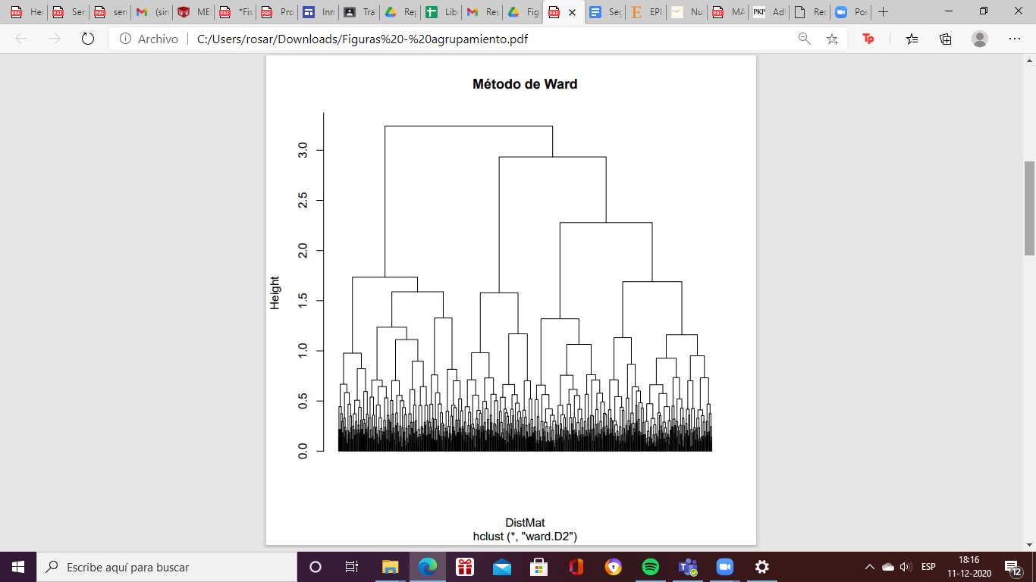

# **Figure S2.** Average Silhouette coefficient for each of the 7 clusters formed by the k-medoids method. The best clusters, in relative terms, are cluster 2 (in green) and 6 (in yellow). The worst cluster is 4 (in cyan).

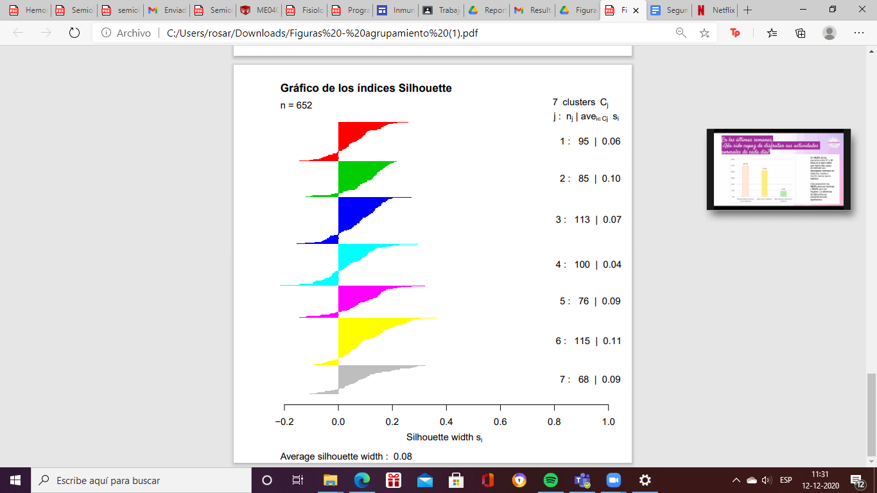

# **References**

1. Alfaro J, Simal A, Botella F (2000). Tratamiento de la diabetes mellitus. Inf. Ter. Sist. Nac Salud. 24(2):33-43. Recuperado el 30 de mayo del 2021 de: [Corel Ventura - TERA24-2.CHP (sanidad.gob.es)](https://www.sanidad.gob.es/eu/biblioPublic/publicaciones/docs/mellitus.pdf)
2. Durán Agüero J, Carrasco Piña E, Araya Pérez M (2012) Alimentación y Diabetes. Rev Nutr Hosp 27:1031-1036. doi: <https://dx.doi.org/10.3305/nh.2012.27.4.5859>
3. Ghachem, A, Bagna, M, Payette H, Gaudreau P, Brochu, M, Dionne I. J. (2019). Profiling obesity phenotypes and trajectories in older adults of the Quebec NuAge cohort on nutrition and successful aging: A cluster analysis. Clinical Obesity, 9(2), e12295. <https://doi.org/10.1111/cob.12295>
4. González Hita, M., Sandoval Rodríguez, A. S., Román Maldonado, S. M., & Panduro Cerda, A. (2001). Obesidad y diabetes mellitus tipo 2. *Investigación en Salud*, *III*(1), 54–60. Recuperado de <https://www.redalyc.org/articulo.oa?id=14230108>
5. Leiva AM, Martínez MA, Petermann F, Garrido A, Poblete F, Díaz X, Celis C (2018) Factores asociados al desarrollo de diabetes mellitus tipo 2 en Chile. Nutr. Hosp. 35(2):400-407. doi: <http://dx.doi.org/10.20960/nh.1434>
6. Mohammadi, S., Hajhashemy, Z., & Saneei, P. (2022). Serum vitamin D levels in relation to type-2 diabetes and prediabetes in adults: a systematic review and dose-response meta-analysis of epidemiologic studies. *Critical Reviews in Food Science and Nutrition*, *62*(29), 8178–8198. doi: <https://doi.org/10.1080/10408398.2021.1926220>
7. Rodríguez M, Mendoza MD (2019) Factores de riesgo de diabetes mellitus tipo 2 en población adulta. Barranquilla, Colombia. Rev ACE 6(2):86-91. doi: <https://doi.org/10.53853/encr.6.2.482>
8. Sapunar J (2016) Epidemiología de la Diabetes Mellitus en Chile. Rev. Med. Clin. Condes 27(2):146-151. doi: <https://doi.org/10.1016/j.rmclc.2016.04.003>
9. Sartorius, N. (2018). Depression and diabetes. *Dialogues in Clinical Neuroscience*, *20*(1), 47–52. doi: <https://doi.org/10.31887/DCNS.2018.20.1/nsartorius>